21st-century skills
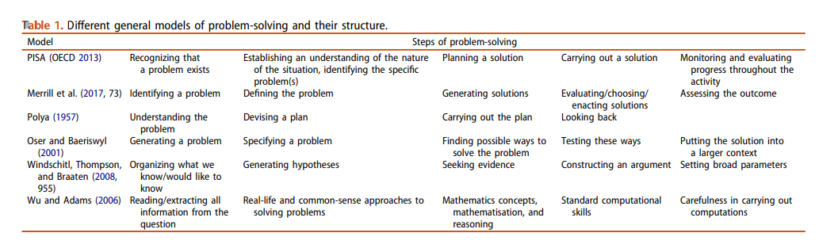
- Problem Solving
A framework to foster problem-solving in STEM and computing education Burkhard Priemer, Katja Eilerts, Andreas Filler, Niels Pinkwart, Bettina Rösken-Winter, Rüdiger Tiemann & Annette Upmeier Zu Belzen

A Problem-Solving Taxonomy (PST) Most, if not all, problem-solving activities can be divided into five classifications: routines, diagnosis, strategy, interpretation, and generation.
There is no particular sequence for these classes of activity and in solving an actual problem the student will move back and forth among them according to the dictates of the particular problem. The following working definitions have been evolved for these activities:
Routines are those operations which, once begun, afford no opportunity for decision but proceed by simple or complex mathematical steps to a unique solution. Long division is a routine. The evaluation of a complex integral is a routine. The solution of a quadratic equation is a routine. The determination of the moment of inertia of a composite area about a centroidal axis is a routine. All of these depend only on the correct execution of a number of steps. The student may find it necessary to recall mathematical or physical facts in order to perform a routine but no decisions are necessary.
Diagnosis is the selection of the correct routine or routines for the solution of a particular problem. Diagnosis is sorting out correct routines from incorrect routines. Deciding on the flexure formula to find the stresses at a given point in a beam is diagnosis. Deciding on integration by parts for a given integration problem is diagnosis. In both cases there is only one way to go, but the student must find it. He must examine the problem until he finds a correct routine.
Strategy is the choice of a particular routine for the solution of. a problem which may be solved by several routines or variations of routines, all of which are known to the student. Strategy is choosing among correct routines. The selection of a point about which to take moments is a strategy decision. The decision to use polar rather than Cartesian coordinates is strategy. The use of the method of sections or of the method of joints in analyzing a truss is a matter of strategy.
Interpretation is the reduction of a real-world situation to data which can be used in a routine, and the expansion of a problem solution to determine its implications in the real world. It includes the making of appropriate assumptions and the interpretation of results.
Generation is the development of routines which are new to the problem-solver. It may simply be laying out a number of routines to put them together in new ways, in which case it is probably a matter of pure recall. It may be the bringing together of previously unrelated ideas to spark a new attack, in which case it is highly creative. It may be somewhere between these two extremes. It must result in an activity which is completely new to the problem-solver and which he has never been taught.
A Taxonomy of Problem-Solving Activities and Its Implications for Teaching H. L. Plants, R. K. Dean, J. T. Sears, and W. S. Venable College of Engineering, West Virginia University

PISA 2012 Problem-Solving Framework
Definition of a problem: A problem exists when a person has a goal but doesn’t know how to achieve it (Duncker, 1945). This definition is enlarged upon in Figure 4.1. The given state (givens) is the knowledge the person has about the problem at the outset, and the operators are the admissible actions that can be performed to achieve the desired goal state (outcomes) with the assistance of the available tools. Barriers that must be overcome (e.g. lack of knowledge or obvious strategies) stand in the way of achieving the goal. Overcoming the barriers may involve not only cognition but also motivational and affective factors (Funke, 2010).
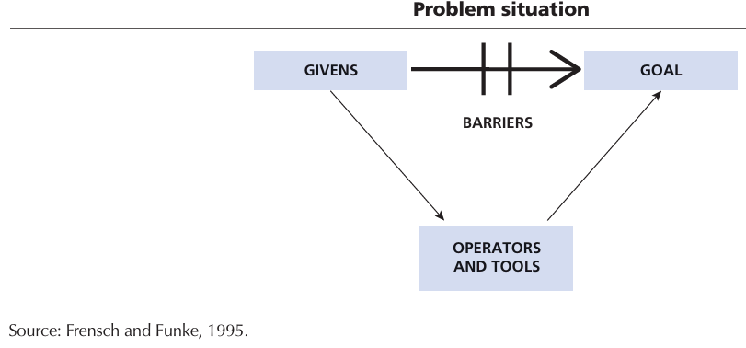
Definition of problem-solving
Consistent with this understanding of what is meant by a problem, Mayer (1990) defines problem-solving as cognitive processing directed at transforming a given situation into a goal situation when no obvious method of solution is available. This definition is widely accepted in the problem-solving community (e.g. see Klieme, 2004; Mayer and Wittrock, 2006; Reeff et al., 2006).
Definition of problem-solving competency
The PISA 2012 definition of problem-solving competency is grounded in these generally accepted meanings of “problem” and “problem-solving.” It is as follows:
Problem-solving competency is an individual’s capacity to engage in cognitive processing to understand and resolve problem situations where a method of solution is not immediately obvious. It includes the willingness to engage with such situations in order to achieve one’s potential as a constructive and reflective citizen.
Problem-solving processes
Different authors conceive of the cognitive processes involved in solving a problem in different ways, but there is a great deal of commonality in their views. The processes identified are derived from the work on problem-solving and reasoning of cognitive psychologists (e.g. Baxter and Glaser, 1997; Bransford et al., 1999; Mayer and Wittrock, 1996, 2006; Vosniadou and Ortony, 1989), as well as by the seminal work of Polya (1945). Additionally, recent work on complex and dynamic problem-solving (Blech and Funke, 2005, 2010; Funke and Frensch, 2007; Greiff and Funke, 2008; Klieme, 2004; Osman, 2010; Reeff et al., 2006; Wirth and Klieme, 2004) has been taken into account.
No assumption is made that the processes involved in solving a particular problem are sequential or that all of the processes listed are involved in solving a particular problem. As individuals confront, structure, represent and solve authentic problems representing emerging life demands, they may move to a solution in a way that transcends the boundaries of a linear, step-by-step model. Most of the information about the functioning of the human cognitive system now supports the view that it is capable of parallel information processing (Lesh and Zawojewski, 2007).
For the purposes of the PISA 2012 problem-solving assessment, the processes involved in problem solving are taken to be:
• Exploring and understanding
• Representing and formulating
• Planning and executing
• Monitoring and reflecting
Exploring and understanding
The objective here is to build mental representations of each of the pieces of information presented in the problem. This involves:
• exploring the problem situation: observing it, interacting with it, searching for information and finding limitations or obstacles; and
• understanding given information and information discovered while interacting with the problem situation; demonstrating understanding of relevant concepts.
Representing and formulating
The objective here is to build a coherent mental representation of the problem situation (i.e. a situation model or a problem model). To do this, relevant information must be selected, mentally organised and integrated with relevant prior knowledge. This may involve:
• representing the problem by constructing tabular, graphical, symbolic or verbal representations, and shifting between representational formats; and
• Formulating hypotheses by identifying the relevant factors in the problem and their interrelationships; organising and critically evaluating information.
Planning and executing include:
• planning, which consists of goal setting, including clarifying the overall goal, and setting sub-goals, where necessary; and devising a plan or strategy to reach the goal state, including the steps to be undertaken; and
• executing, which consists of carrying out a plan.
Monitoring and reflecting include:
• monitoring progress towards the goal at each stage, including checking intermediate and final results, detecting unexpected events, and taking remedial action when required; and • reflecting on solutions from different perspectives, critically evaluating assumptions and alternative solutions, identifying the need for additional information or clarification and communicating progress in a suitable manner.
Reasoning skills
Each of the problem-solving processes draws upon one or more reasoning skills. In understanding a problem situation, the problem solver may need to distinguish between facts and opinion; in formulating a solution, the problem solver may need to identify relationships between variables; in selecting a strategy, the problem solver may need to consider cause and effect; and, in communicating the results, the problem solver may need to organise information in a logical manner. The reasoning skills associated with these processes are embedded within problem solving. They are important in the PISA context since they can be taught and modelled in classroom instruction (e.g. Adey et al., 2007; Klauer and Phye, 2008). Examples of reasoning skills employed in problem solving include deductive, inductive, quantitative, correlational, analogical, combinatorial and multidimensional reasoning. These reasoning skills are not mutually exclusive and often in practice problem-solvers move from one to another in gathering evidence and testing potential solution paths before settling into the major use of one method over others in finding the solution to a given problem. Reasoning skills have been broadly sampled across the assessment items because the difficulty of an item is influenced by the complexity and types of reasoning involved in its solution.
Examples

Operational Coding
- All 21st CS occurs with contextual themes that define them. For example, PS occurs when a problem is posed in front of students (either hypothetical or taken from a book). In the context of classroom education, it is very important for us to figure out when the problem started so that we can state that there is an opportunity for PS. In cases where the teacher announces that he or she is going to solve a problem (especially for numerical problems in math and science), it is pretty apparent that a problem is being posed in front of students, and encoding PS is straightforward. However, in many scenarios, we have to define which type of question can be called a problem. According to the global encoding definition, generally, problems mentioned in the “Assessment” section fall into the category of problem-occurring scenario, and questions asked in the “Teaching” section fall into the category of problem-not-occurring scenario. Finally, a question can be called a problem depending on the intent of the teacher and the way the teacher is posing the question. The following rules were made to differentiate between the situation of the problem-occurring case and the problem-not-occurring case.
- Problem not occurring scenarios
    - During the “teaching” section, questions (What and Why type) asked to remember data type material or clarify the meaning of the topic should not constitute the occurrence of PS. The PS occurs when students are posed with a problem, and they have to solve it.

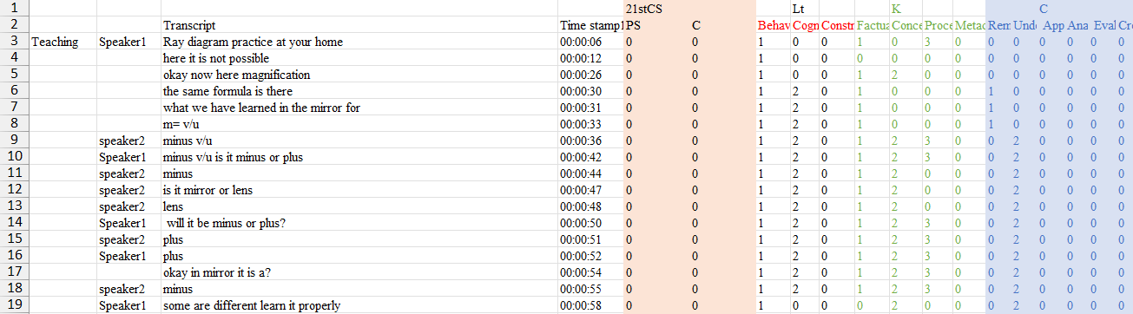
    - In math classes, if the teacher is proving a formula or theorem as part of teaching, then it is not problem-solving.
    - In some science classes, after teaching the concept (DNA translation), the teacher asked students to explain it in their own words in the “assessment” section of the class. Simply explaining a definition does not follow the structure of a “problem” as articulated above, and hence, these scenarios have not been included as an example of PS. (12th Bio class and 6th Sci class, where the teacher has taken the students outside to the garden)
    - If Metacognitive Knowledge is occurring, then generally PS (Monitoring and Reflecting) should not occur as MK should not be subject specific, whereas PS (Monitoring and Reflecting) is going to be problem specific.

- Problem-occurring scenarios
    - The teacher writes on the board “problem 1 or Ex 1”, etc. and asks students to solve a question or start dictating data/information about a question.
    - The teacher asks students to come to the blackboard and solve a question or prove a theorem.
    - The teacher asks students to prove a theorem in their copy.

- Once it has been decided that the problem is occurring, we can use the PISA 2012 taxonomy to recognise the processes involved in problem-solving, which are as follows:
• Exploring and understanding
• Representing and formulating
• Planning and executing
• Monitoring and reflecting
Examples
- Exploring and understanding
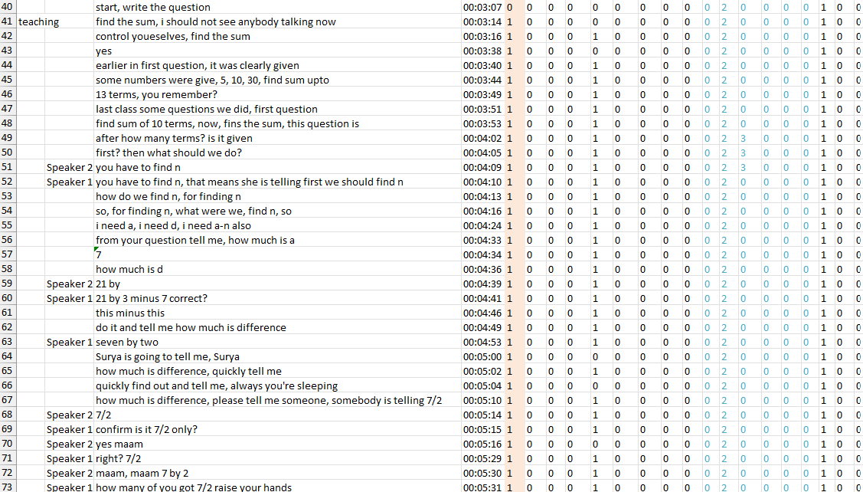
20220801_101555_10a_math_ah

- Representing and formulating
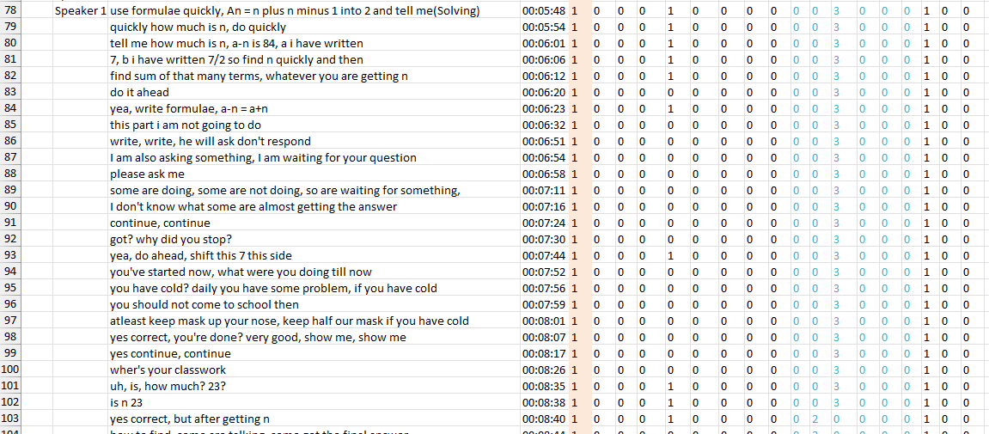
20220801_101555_10a_math_ah

- Planning and executing
20220801_101555_10a_math_ah

- Monitoring and reflecting
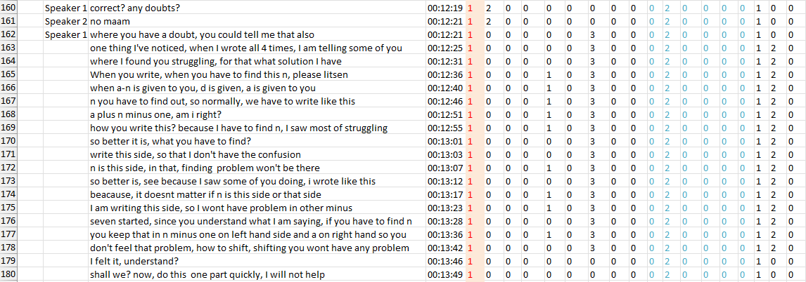
20220801_101555_10a_math_ah

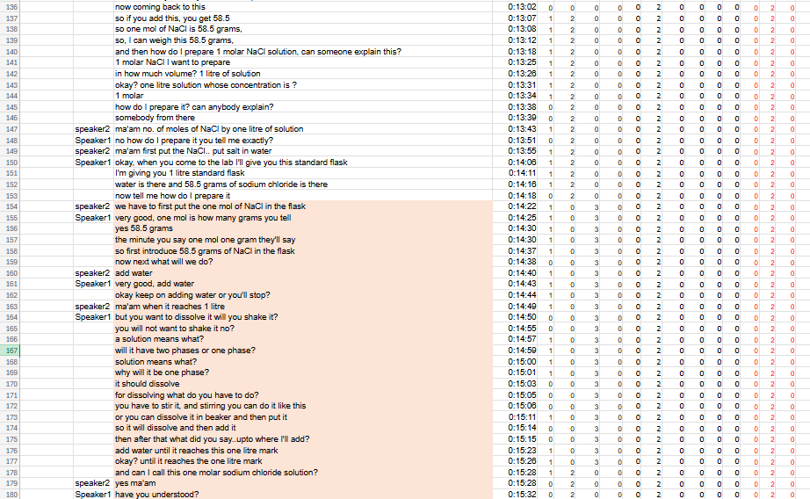
17_08_chem_tr
- According to modern definitions, a problem exists when there is a goal but no known method to reach it [1]. In the chemistry lesson excerpt, the goal was clear: prepare a 1 mol/L (1 M) NaCl solution in a 1-liter volumetric flask. Initially, the method of achieving this was not fully outlined to the students, so they had to figure out the steps. This fits Duncker’s definition and the PISA framework: there is a goal (the desired solution) and the student must discover how to reach it, so a problem is present [1]. The given values were the molar mass of NaCl (58.5 g per mole) and the flask volume (1 L), and the operators were the laboratory actions (weighing, adding water, and stirring). The student had to overcome barriers (applying the mole concept, mixing procedure) through cognition and guidance. By PISA’s definition, problem-solving involves cognitive processing to transform a given situation into a goal state when no obvious solution is immediately available [2] . Here, the student engaged exactly in those cognitive steps. The student and teacher discussed converting moles to grams (58.5 g NaCl per mole) and deciding how to mix the salt with water to reach 1 L. These steps are not trivial computations, but require understanding and planning. In this sense, the student is resolving the problem situation by selecting and executing actions (weighing 58.5 g of NaCl, adding it to water, stirring, and filling to the 1 L mark) to achieve the goal. This matches PISA’s statement that problem solving is “cognitive processing directed at transforming a given situation into a goal situation” when the method is not obvious [2]. The student is actively engaging in cognitive processes (unit conversions, procedure planning) to reach the goal. In fact, PISA 2012 defines problem-solving competency as the capacity to use cognitive processing to understand and resolve situations “where a method of solution is not immediately obvious” [3], which is the case in the classroom exchange. Thus, the activity qualifies as problem solving rather than mere routine instruction. 3 2 The scenario also exemplifies the key problem-solving processes identified by the PISA framework [4] :
- Exploring and Understanding: The student and teacher first identify and interpret the given information. The student realizes that one mole of NaCl corresponds to 58.5 g, and the goal is a 1 M solution in 1 L. This involves understanding relevant concepts (mole, molarity, volume) and recognising the requirements of the task.
- Representing and Formulating: They then construct a mental model of the problem. The student links the abstract goal (1 M solution) to concrete steps: “weigh 58.5 g of salt, then dilute to 1 L.” The molar mass and volumetric flask create a numerical and procedural representation of the goal. Any relevant relations (mass = moles × molar mass, final volume = 1 L) are formulated.
- Planning and Executing: Next, they devise and carry out a plan. As the teacher prompts, the student outlines the steps: add the weighed NaCl to the flask, then add water up to the 1 L mark, and stir to dissolve. These steps are planned sub-goals (weigh salt, pour water, mix) and then executed in the lab.
- Monitoring and Reflecting: During execution, there is monitoring: the teacher checks that the solution is one-phase (salt is fully dissolved) and that the final volume reaches the mark. If issues arise (e.g. salt not dissolving easily), they discuss stirring or pre-dissolving as remedial actions. At the 1 end, they reflect by confirming that the solution at 1 L is indeed 1 M. These checks ensure the goal is correctly achieved. Each of these stages corresponds to PISA’s problem-solving components[4] . For example, when the teacher asks about dissolving the salt, they are ensuring the student understands that a solution must be homogeneous (monitoring). When the student calculates 58.5 g for one mole, they are representing the problem mathematically (representing). When they plan “add water until 1 L mark,” they are executing the plan. All these show active cognitive engagement with the problem situation. [1] Conclusion: Yes, this classroom exchange does involve a genuine problem: preparing a 1 M NaCl solution from basic information. The student had to figure out how to achieve the goal, meeting the formal definition of a problem . Furthermore, the steps taken in the dialogue embody the processes of problem solving (understanding, representing, planning, monitoring) as outlined by PISA . Therefore, this scenario can indeed be classified as an example of problem solving under the 21st-century skill framework. The student demonstrated problem-solving competency by engaging in cognitive processing to transform the given data (molar mass, volume) into the goal state (a correctly prepared 1 M solution) . 1 2 4 3 4 2 3 Sources: The analysis is based on the definitions and process model from the PISA 2012 problem-solving framework , which describe what constitutes a problem and how problem-solving occurs. 1 2 3 4 PISA 2012 Problem Solving Framework https://www.oecd.org/content/dam/oecd/en/topics/policy-sub-issues/student-problem-solving-skills/46962005.pdf

Final Operational Coding for Problem Solving
Type of rules | Problem solving (PS) | Creativity (C) | Collaborative Learning (CL) | Critical thinking (CT)
Decision rules | Encode as PS when activities involve understanding the problem, planning/executing solutions, or monitoring and reflecting on outcomes | Identify utterances, describing fluency and flexibility | Encode utterances that show group planning, shared decision-making, idea sharing, peer support, or reflection on group processes | Code as CT when interactions involve reasoned analysis, evaluation of evidence, inference, argument construction, or reflection on reasoning
Inclusion criteria | - Teacher asks students to solve a problem or prove a theorem  - The teacher asks the student to come to the blackboard and solve a problem  - Identifying and interpreting the given information before solving a problem  - If the teacher/student is giving a reflection from their side while solving a problem | - If the teacher asks to write down/list as many things/improvements/methods, etc., as possible related to the question  - Design and draw a picture and point out the name and function of each part of a machine. | - Group Formation  - Setting clear guidelines and assigning specific roles to students  - Clear task breakdown and resource distribution  - Inviting each student to articulate their reasoning.  - Groups hand over their setup cleanly and prepare for the next  - Students diagnose and correct errors together  - Teacher prompts groups to verify their results before proceeding | - Teacher explicitly identifies or explains the structure of questions and corresponding solution strategies, thereby categorising component parts of reasoning.  - The teacher asks which is correct between options A and B (Comparing)  - If the teacher is telling the meaning, analogies and application in real life of a concept (Clarifying meaning)  - If the teacher is asking a “why” or “because” type of question  - If students are correcting other students or the teacher  - Looking at the problem from multiple perspectives
Exclusion criteria | - Formula derivation/ proof  - Explaining a definition  - MK is occurring | - Write/list down two examples  - Listing closed-ended and fact-based answers from recall | If the teacher explains theoretical concepts prior to conducting the experiment. | - If the teacher is giving a reflection from their side  - Giving/listing as many examples as possible of something  - answering by recalling (single word answers)
Boundary conditions | The teacher asks to devise a plan to do an activity coded as PS | Open-ended prompts to observe and list features in a given diagram are coded as Creativity. | Interactions where the teacher demonstrates and explains an experiment while students observe or follow along, encoded as CL. | - Defining the concept in own words is Und and not CT  - Pure dictation of definitions or prompts to write terms does not count as Critical Thinking

